NEXTA HW1

**Problem 1:** How many nodes are in the West Jordan network? How many zones are in the West Jordan network?

149 nodes

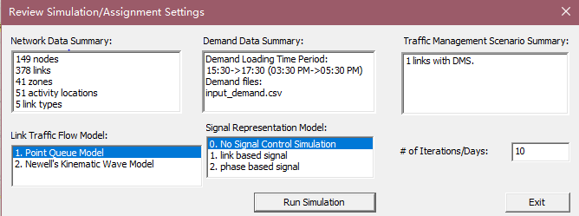

**Problem 2:** What is the speed limit along 9000 South? How many lanes are present along 9000 South in the Base Condition model?

Speed limit is 32 and 2 lanes. 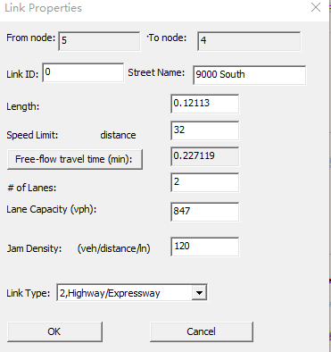

**Problem 3:** What is link capacity? How is it different from lane capacity?

Link capacity is maximum hourly rate at which persons or vehicles can move in a reasonable order of a link, during a period of time under the prevailing conditions of path, traffic and control. A link can have multiple lanes. Compare link capacity and lane capacity, they would have same unit, but link capacity would be the sum of all capacity of lanes in this link.

**Problem 4:** Describe the link capacity on Redwood Road in the West Jordan Network (how link capacity varies by location, point out bottlenecks, etc.). It might also be a good idea to include the average link capacity and/or use a histogram.

Hints: You can find file input_link.csv in the project folder (NEXTA menu->file->open project folder->locate input_link.csv) and use Excel to generate the histogram for the link capacity for all links with names of Redwood.

The graph shows how link capacity varies by location, from number 1 to 30 corresponds to node origins 5017 to 11172. I observed that the bottlenecks start from 9th link to 17th link. The average link capacity is 2193.8 vph. So when I did this problem, I used number of lanes times lane capacity to generate link capacity.

**Problem 5:** What is the number of agents/vehicles to be simulated, as reported in the output_summary.csv file?

I ran it in Newell's Cumulative Flow Count Model with 30 iterations. This simulation has 25282 vehicles.

**Problem 6:** The first large table in the output_summary.csv file describes summary statistics for each iteration of the simulation. What was the average travel time, average trip time index, average speed, and network clearance time (in minutes) for the last iteration? What pattern do you observe in the average travel times and speeds as the iteration number increases? (Plots might be useful to display these patterns/trends.)

In my 30th iteration, the average travel time is 7.12559 mins, average trip time index is 1.29228, average speed is 25.923, and 1350 mins for network travel clearance time.

With increasing number of iterations, the average travel time decrease to a steady value.

With increasing number of iterations, the average speed was increasing to a steady value.

**Problem 7:** Similar to Problem 6, use the first large table in the output_summary.csv file to find the average travel time, average trip time index, average speed, and network clearance time (in minutes) for the last iteration? Do you notice many differences in these values compared to the results for the “no work zone” model?

The average travel time is 6.5063, average trip time index is 1.1643, average speed is 27.9374 and 1440 for network clearance time. Comparing to previous simulation, it has less average travel time, average trip time index, higher average speed and longer network travel clearance time.

**Problem 8:** Following the procedure described in Step 5, use screen captures to provide Link MOE plots for Lane Volume and Speed (in MPH), with 15-minute aggregation intervals, for both links between Node 1 and Node 2 (both directions). This should result in 4 images.

In base condition

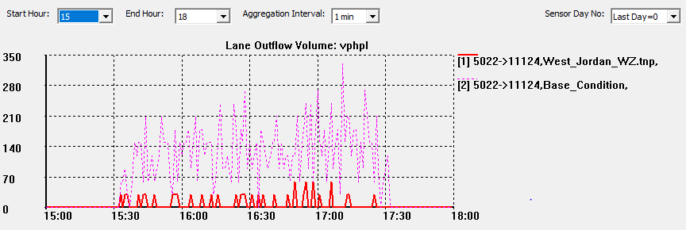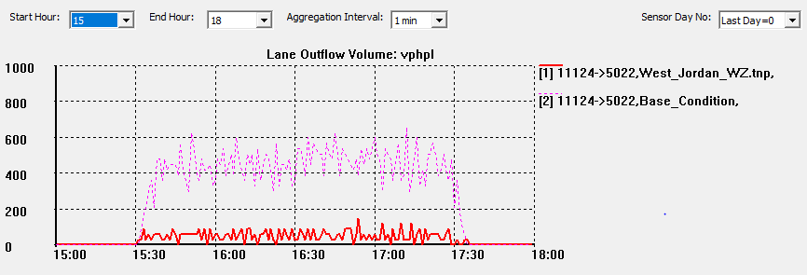

In work zone condition

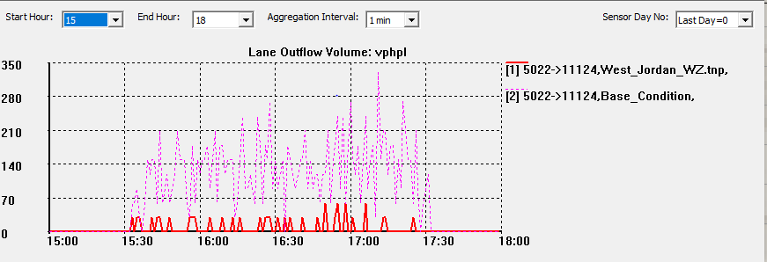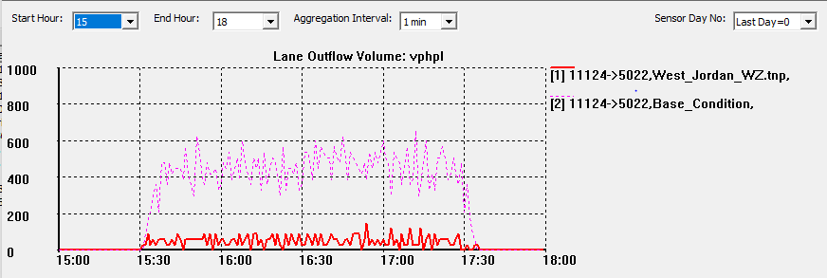

**Problem 9:** From the plots generated in Problem 8, did you notice any differences in speed and volume on these links between the two networks (with and without the work zone)? Do the differences in speed/volume make sense? Does one direction of travel experience more congestion?

From my graphs, they seem has no much difference. However, the simulation result is different. And yes form graph we can observed that one direction is more congestion.